**Dynamic Load Component**

**Abstract:** A pop-up ad is a form of online advertising that appears as a separate window or tab that opens up on top of the current webpage. They can be effective in generating clicks and conversation, but they are also often considered annoying and intrusive by users.

**Introduction:**

A popup ad is a type of online advertising that appears as a small window or dialogue box on top of a website's content. Here is how it typically works:

1. The website owner or ad network embeds code into the website’s HTML that triggers the popup ad when certain conditions are met. For example, the code may be programmed to display the popup when a user lands on a certain page or clicks on a particular link.
2. When the conditions are met, the popup ad is loaded and displayed on top of the website's content. This is typically done using JavaScript or a similar programming language.
3. The popup ad may contain a message, image, or video promoting a product or service. It may also contain a form or button for the user to interact with, such as to sign up for a newsletter or make a purchase.
4. Some popup ads may be programmed to automatically close after a certain amount of time or when the user clicks on a button within the ad. Others may remain open until the user manually closes them.

Popup ads are often considered intrusive and annoying by users, which is why many web browsers now have built-in popup blockers that prevent them from appearing. However, some websites and advertisers still use them as a way to generate revenue and promote their products or services.

**Required Languages:**

* Html
* CSS
* Js

**Flowchart / design:**

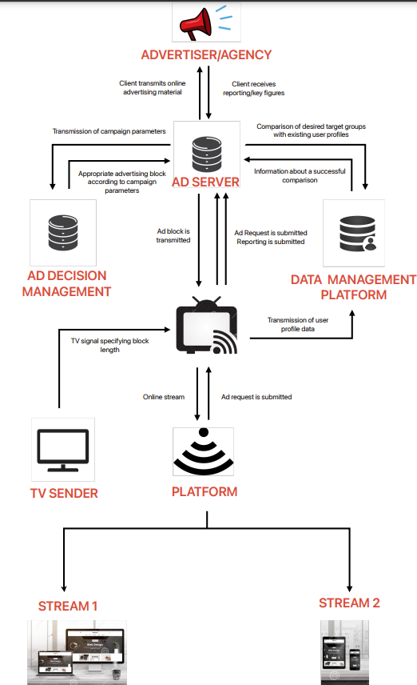

**Sample output:**

**Sample link: https:** https://n1dclk.csb.app/

